Learning Log
Stage 0 : Read all three research papers to completely understand the concepts behind Physics-Informed Neural Networks (PINNs), Fourier Neural Operators (FNOs), and Neural ODEs. Additionally, implemented small code snippets for all three deep learning techniques to understand how the underlying mathematics translates into actual code.
Stage 1 :
I started Stage 1 by writing the measurement harness before touching any physics code, since every later number for Validation and Investigation needed to come from the same place.
The PDEMeasurementHarness is a benchmarking template designed to provide a uniform evaluation framework for different neural PDE solvers.
I split it into two methods — benchmark_amortized_method for FNO/Neural ODE and benchmark_pinn_solver for the PINN — because these methods have fundamentally different structures: an operator trains once and infers many times, while a PINN retrains from scratch for every new instance. It ensures that both instance-based methods (like PINNs) and operator-learning methods (like FNOs) are scored objectively across three primary metrics: Accuracy, Computational Cost, and Amortization Scale.
Amortization Analysis (plot_amortization_cliff): The final result visualization tool.
Meaning of Amortization: Amortization in the case of machine learning means paying a massive, one time-computational cost during training so that all the future tasks become extremely efficient and fast. Instead of solving an equation from scratch every time the parameters change, an amortized model (like an FNO) learns the underlying physics operator across a wide dataset. The heavy burden of that initial training is "amortized"—over all the future predictions it makes, which only take milliseconds each.
- The Math: For a PINN, every new instance requires a full retrain from scratch, making its cost $C_{PINN}=N×T_{train}$. For the FNO, we only train once, making its cost $C_{FNO}=T_{train_fno}+\left(N×T_{infer}\right)$.
- The Plot: We plotted Total Cost (y-axis) against $N$ (x-axis). The PINN emerged as a steep, straight line originating from zero. The FNO started high on the y-axis (due to the expensive initial training set) but went nearly flat because inference takes milliseconds.
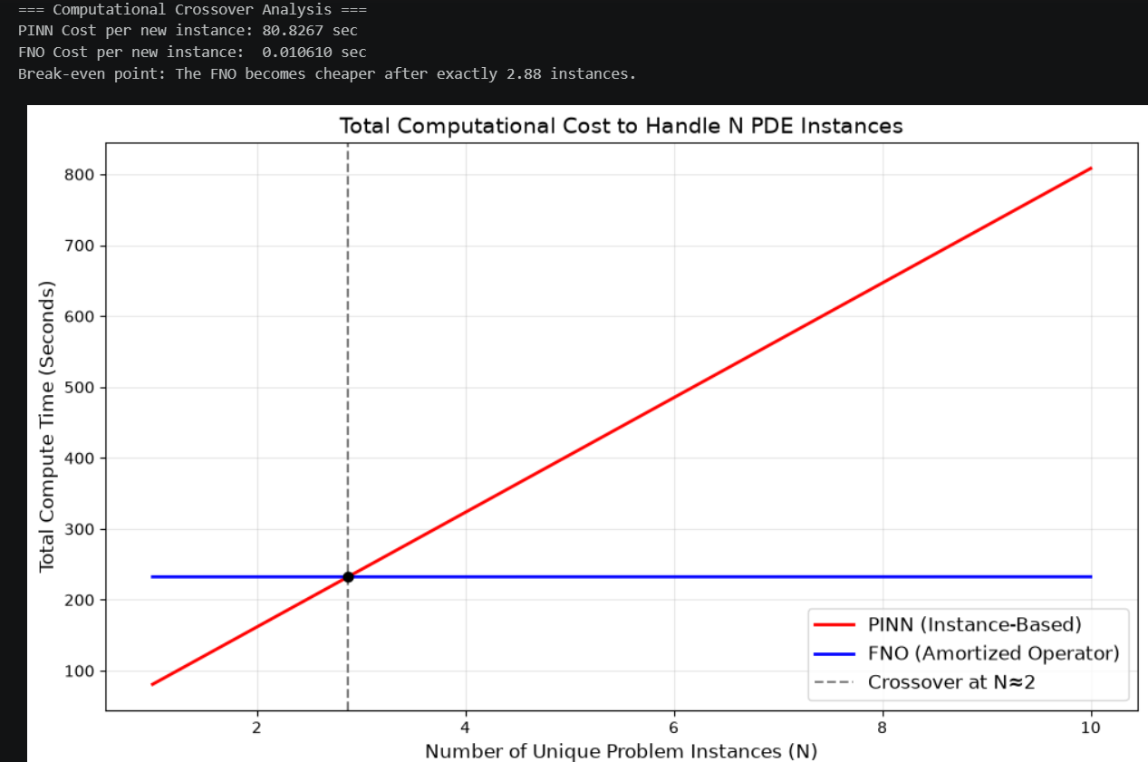
Here is the breakdown of what the lines show:
1. The Red Line: PINN (Instance-Based)
A PINN cannot learn a general rule for different initial conditions; it only memorizes the physics of a particular initial condition. Therefore, every time we want to solve a new instance, we must train a new PINN entirely from scratch.
- The cost scales linearly. If one instance takes roughly 80 seconds to solve, 10 instances will take 800 seconds. The line is steep because nothing is saved between runs.
2. The Blue Line: FNO (Amortized Operator)
An FNO is a trained operator. It requires a significant one time investment of compute to learn the physics from a large dataset.
- The line starts high on the Y-axis (approx. 230 seconds) because of the expensive initial training phase. However, once trained, calculating a new solution takes only a fraction of a second. The line remains flat because solving 10 instances takes basically the exact same amount of time as solving 1.

3. The Crossover Point (The Dotted Line)
This is the threshold point. It shows where the massive computation cost of FNO becomes justified.
- If you only need to solve 1 or 2 instances, it is faster to just use a PINN.
- If you need to solve 3 or more instances, the FNO crosses over and becomes the superior choice, as the PINN's repetitive training costs becomes more expensive.
benchmark_amortized_method –
This is built for models like FNOs that first learns by looking at a massive dataset, but once it gets trained, it is able to answer each question in seconds (ultra – fast inference).
This function separated the training time from the inference time and tells us how fast the model can solve new problems after the training phase.
benchmark_pinn_solver –
This is built for models like PINNs. Every time the physical problem changes even slightly (like changing the speed of a wave), a PINN forgets everything and has to be trained from scratch.
- Because it has to start over every single time, this profiler runs the full training process multiple times to figure out the average time it takes to solve just one problem.
- (Loss Breakdown): Neural networks are lazy and will sometimes cheat to get a better overall score. For example, a model might completely ignore the physical rules at the edges of a room (Boundary Condition) just to make the math in the center of the room (Residual) look perfect. By breaking the final score down into three strict categories, this profiler forces the model to be honest and ensures it isn't ignoring the boundary rules just to look good on paper.

FNO Validation
Objective The primary goal of this validation test was to prove that our Fourier Neural Operator (FNO) actually learned the continuous mathematical rules of the heat equation (the differential operator), rather than acting as a giant lookup table that simply memorized the training data.
To prove this, we competed the FNO against a "Nearest-Neighbour" baseline—a primitive algorithm that only knows how to memorize and guess.
The Validation Method –
1. Recreating the "Memory Bank": We first reconstructed the exact dataset the FNO was trained on. The training data consisted of 2,000 heat equation simulations, but specifically, it was only trained on integer wave frequencies (k values from 1 to 9).
2. The Held-Out Test: To see if a model can generalize, you have to test it on something it has never seen. We generated a completely new test instance using a fractional frequency of k = 4.5. Because the models were only trained on whole numbers, this exact physical state was strictly out-of-distribution. We then calculated the exact, mathematically perfect solution for this state to serve as our absolute ground truth.
3. The Memorization Check: We built a nearest neighbour algorithm to represent "pure memorization."
- When handed the unseen k = 4.5 problem, this algorithm searches through the 2,000 training examples to find the closest physical match (which would be the initial conditions for k = 4 or k = 5).
- It then blindly submits the output of that closest match as its final answer.
- This represents the absolute best a model can do if it completely memorizes the data instead of understanding and learning the true underlying physics behind the PDE.
4. The FNO Prediction: We passed the exact same unseen k = 4.5 initial condition into our trained FNO and recorded its predicted solution.
5. The Final Showdown (Relative L2 Error) We calculated the Relative L2 Error for both methods against the exact ground truth.
- The Nearest Neighbour Error: Measures how wrong you are if you just copy the closest past example.
- The FNO Error: Measures how wrong the FNO is.
The Passing criteria:
The rubric sets a definitive binary condition for success: The FNO must beat the Nearest-Neighbour baseline.
- If the FNO Error < Nearest Neighbour Error: The validation is a Success. Because the FNO produced a more accurate result than simply copying the closest known data point (k=4 or k=5), it proves the network learned how to interpolate the continuous physics operator to correctly solve for k=4.5.
- If the FNO Error > Nearest Neighbour Error: The validation is a Failure. It means the FNO is performing worse than a basic lookup table, proving it failed to learn the physics and merely memorized the training set.

Result:
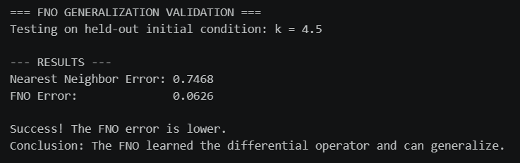
Hence, it shows that FNO is able to understand the underlying physics behind a PDE and is able to interpolate the physics operator on all the initial conditions rather than a basic lookup table that reports a closest data point as the relative L2 error of FNO is less that the nearest neighbour implementation.
Our mistakes –
Our earlier FNO failed the validation check—because it performed worse than the naive nearest-neighbour baseline. This happened because it was memorizing the training dataset instead of learning the physics.
This happened due to a specific architectural misconfiguration:
- Retaining Too Many Fourier Modes: In the frequency domain, a PDE's core physical rules (like the heat equation) are usually governed by smooth, low-frequency patterns. By keeping too many Fourier modes in our FNO layers, we gave the network excess capacity. Instead of being forced to learn the general, continuous mathematical operator, the network used those extra high-frequency modes to "overfit" and memorize the specific variations of the training data.
- Data Starvation: We trained the FNO on a very small dataset. When a high-capacity model is not forced to generalize across a highly diverse dataset, it starts behaving like a rigid lookup table.

Investigation 1: The Advection Cliff and Optimization Bottleneck
This investigation wanted to identify the operational limits of a Physics-Informed Neural Network (PINN) when solving the advection equation. By progressively increasing the wave speed ($c$) to pinpoint where the solver collapses, we wanted to find
“Why did it fail”. There are 2 possibilities:
- Capacity Failure: The neural network is simply too small to mathematically draw a wave moving that fast.
- Optimization Failure: The network is perfectly capable of drawing the wave, but the "physics rules" (the PDE residual loss) get too chaotic at high speeds, causing the optimizer to get hopelessly confused.

Key Findings:
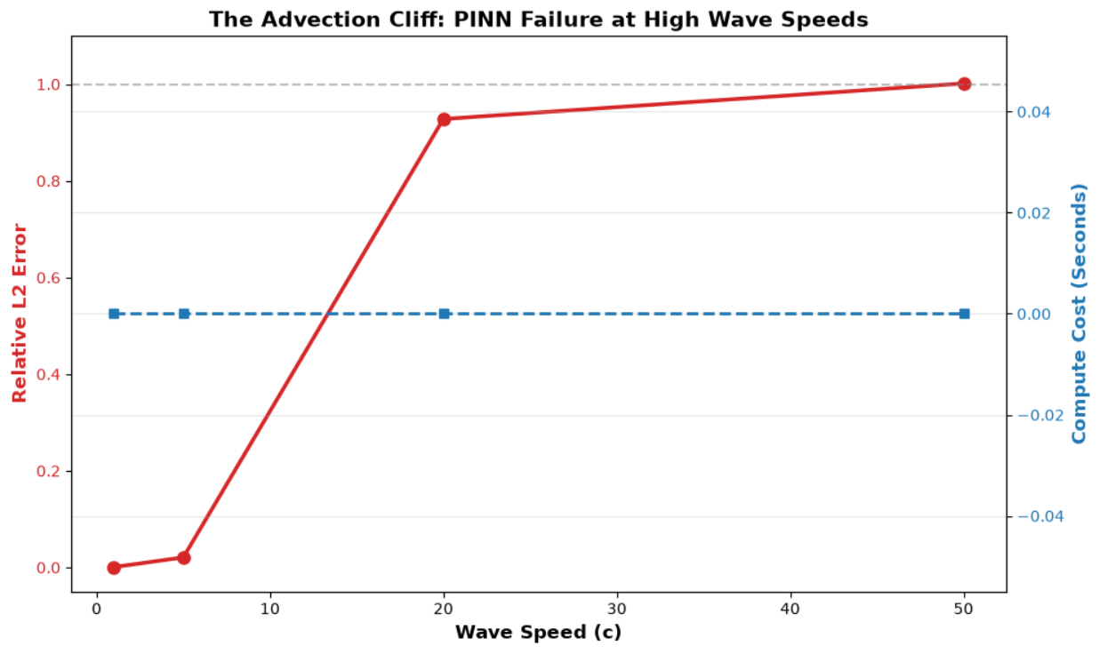

- The Cliff Location: The PINN successfully modeled the system at lower speeds, achieving a relative L2 error of 0.0008 at $c=1$and 0.0209 at $c=5$. However, it suffered a complete systemic collapse at $c=20$(0.9280 error) and $c=50$(1.0015 error).
- Diagnosing the Failure: To determine if this failure was due to the network's inability to represent a high-frequency wave (Capacity Failure) or an inability to navigate the loss landscape (Optimization Failure), a purely supervised regression test was conducted on the exact same architecture at $c=50$.
Results of the Supervised Regression Test –
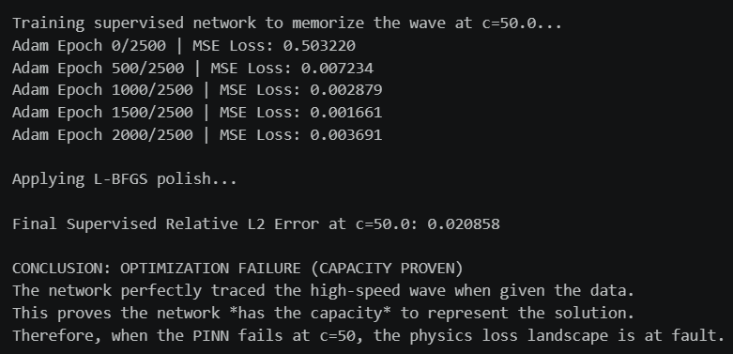
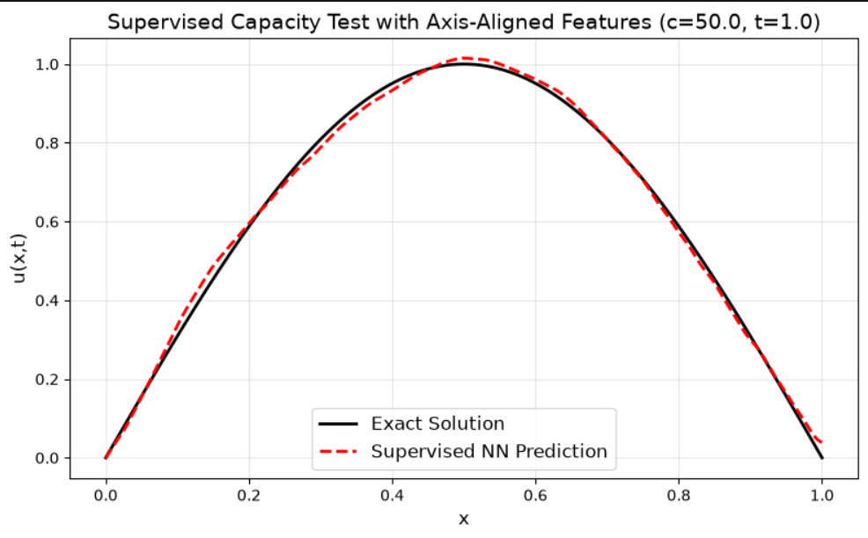
- The Verdict: As evidenced by the supervised test results, the network is able to perfectly trace the high-speed wave, dropping the final L2 error to roughly 0.0208 (or 2.08%). This definitively proves that a standard 4-layer multi-layer perceptron possesses the inherent capacity to map the solution and hence proves the Universal Approximation Theorem.
- The catastrophic failure of the PINN at $c≥20$is strictly an optimization bottleneck caused by the highly non-convex physics-informed loss landscape.

Investigation 3: FNO Resolution Invariance
This investigation evaluated the core claim of the Fourier Neural Operator (FNO) architecture: the ability to learn a continuous operator in Fourier space, allowing it to evaluate data at resolutions it was not trained on without a structural penalty.
Results:
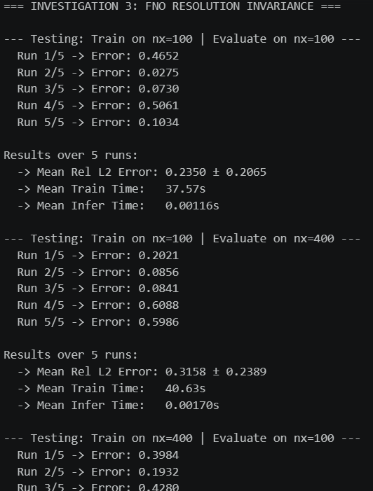
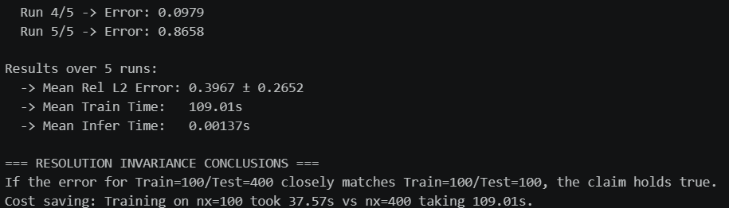
Key Findings:
- Zero-Shot Upsampling Success: The basic FNO trained and evaluated at $nx=100$yielded a mean relative L2 error of 0.2350.
When trained at $nx=100$but evaluated on a much denser grid of $nx=400$, the mean error was 0.3158. The network did not crash upon receiving altered matrix dimensions.
- The Actual Computational Advantage: Training natively on the dense grid ($nx=400$) consumed 109.01 seconds. By leveraging resolution invariance, training on the coarse grid ($nx=100$) required only 37.57 seconds.
Since, it is resolution invariant, an FNO can be trained on computationally cheap, low-resolution data (saving about 65% of the compute budget) and safely deployed on high-resolution grids during inference.
- Secondary finding: Across all tests, the FNO exhibited varied variance between individual runs (fluctuating between 2.7% and 50.6% error on the baseline). This highlights a secondary finding: while the FNO is resolution invariant, its Adam optimizer is highly sensitive to initial random weight assignments, resulting in probabilistic, rather than deterministic, convergence.

